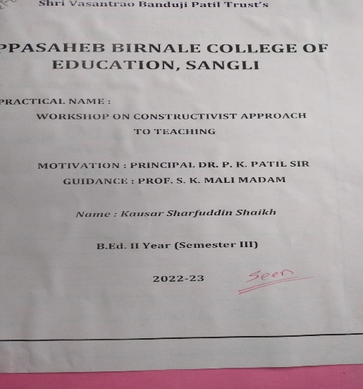

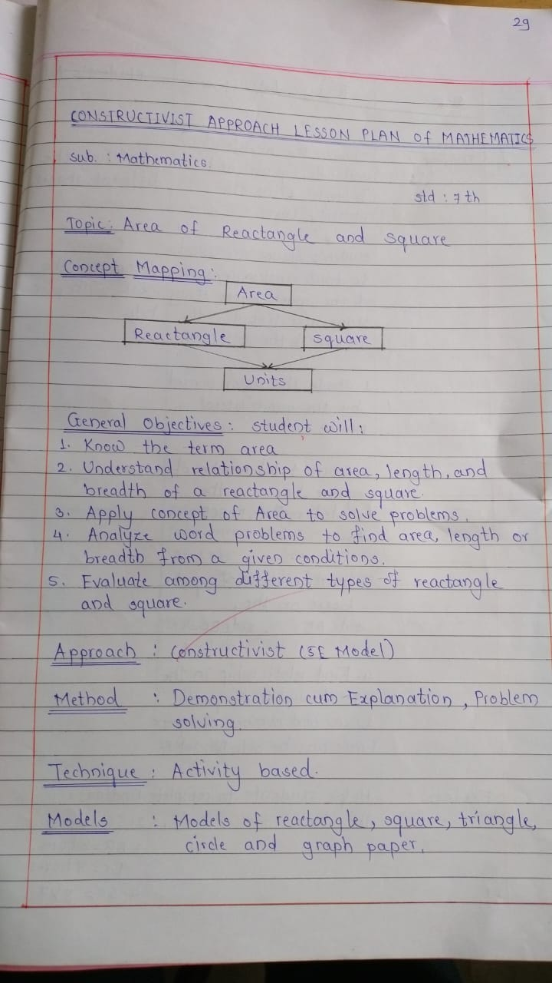

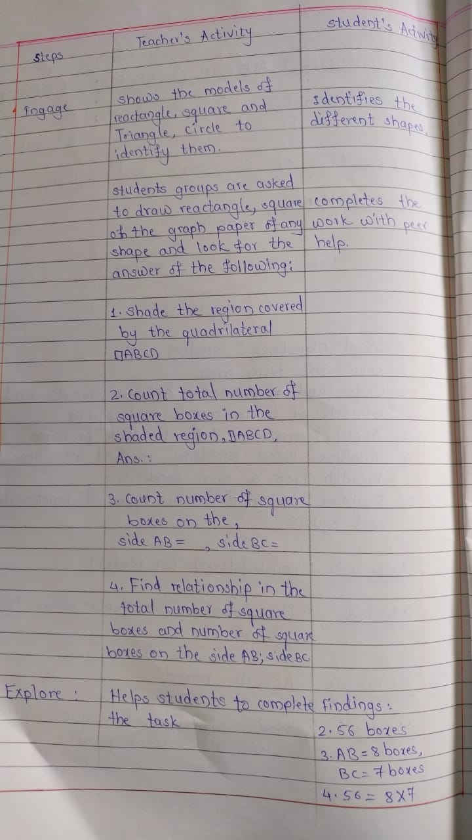

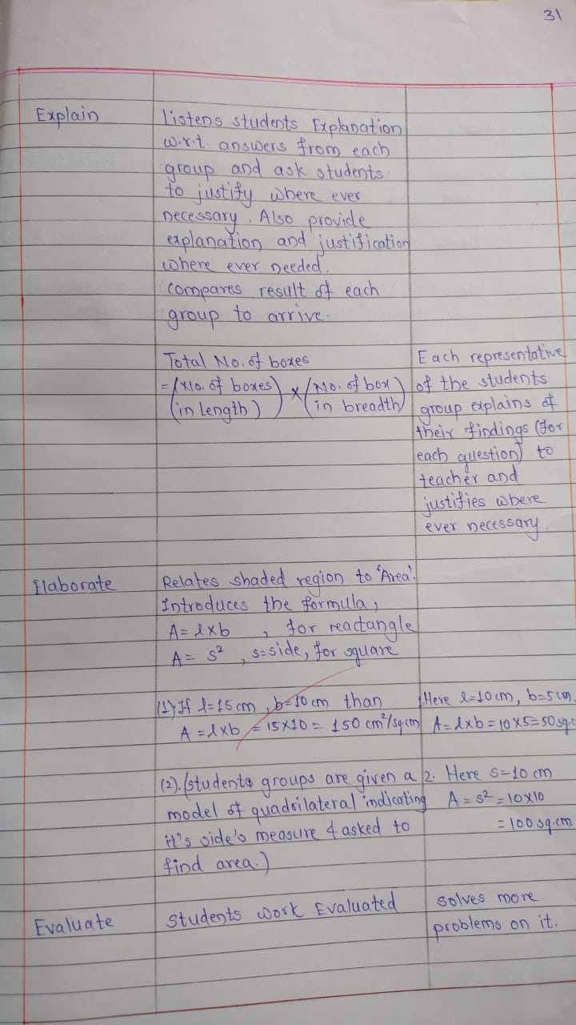

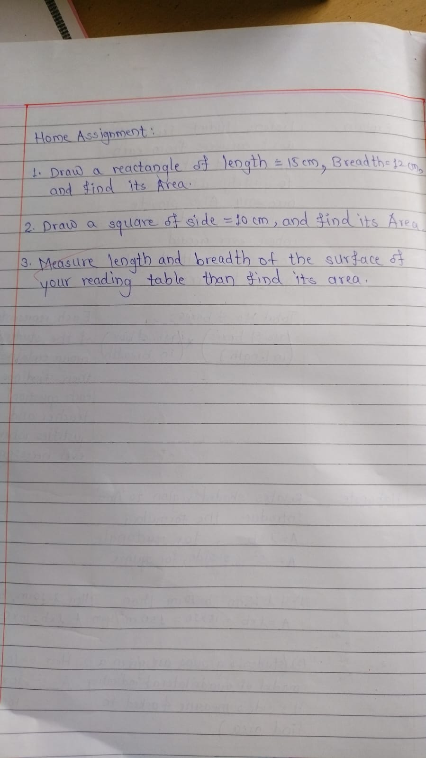

INNOVATIVENESS

Innovation in Education encourages teachers and students to explore research and use the resources to uncover something new. Thus for encouraging innovative thinking in students of our college Efforts are made by teachers and students in different ways.

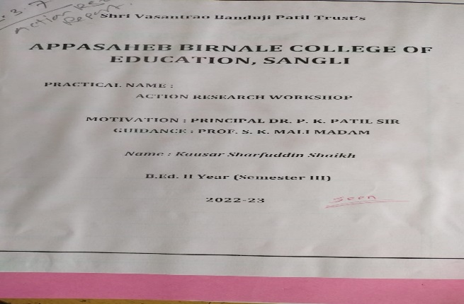

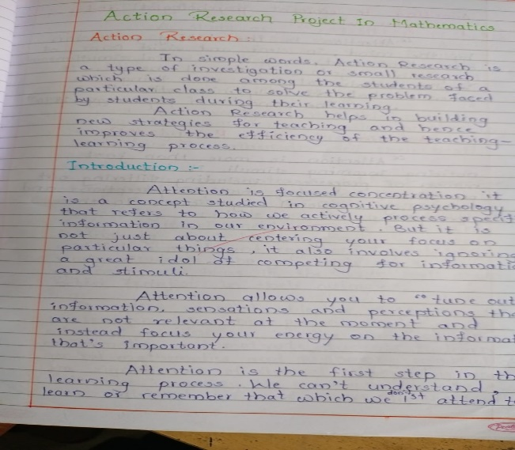

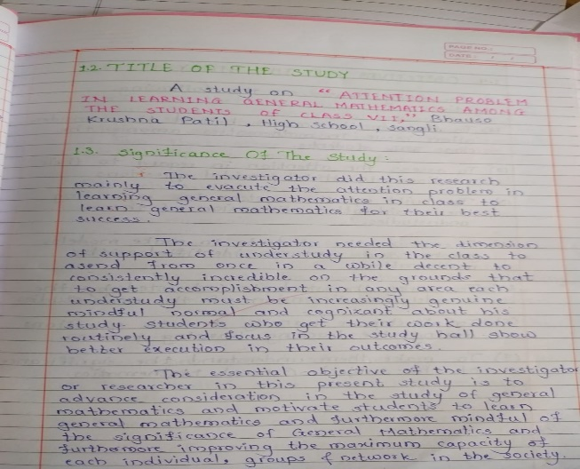

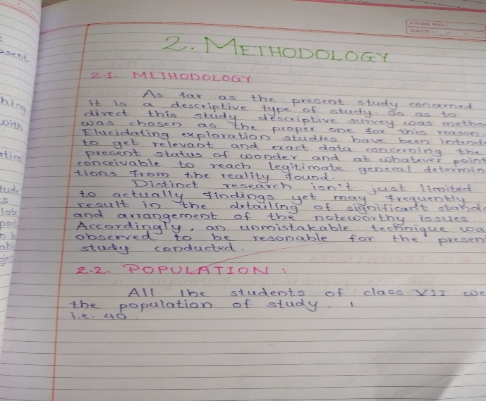

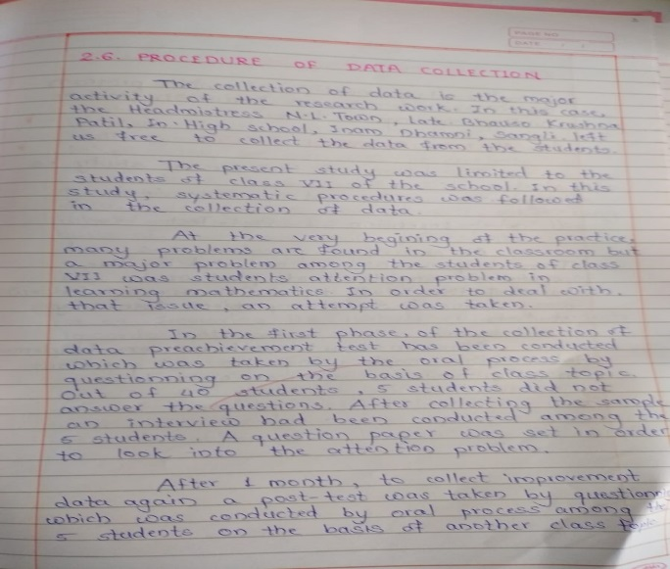

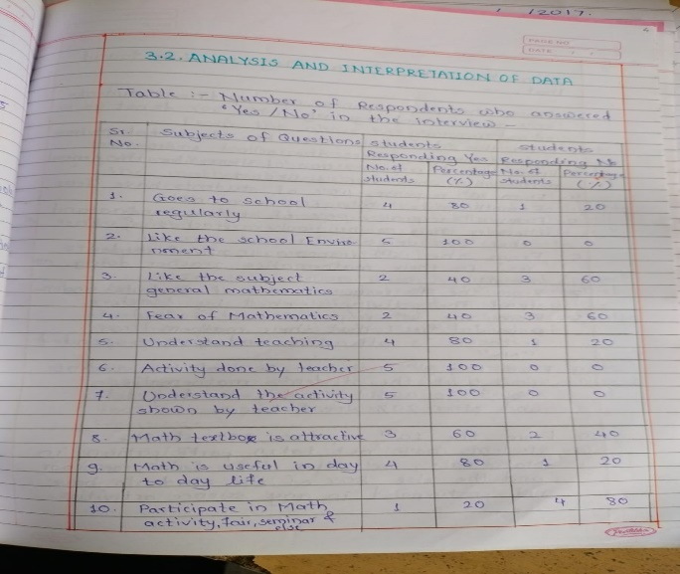

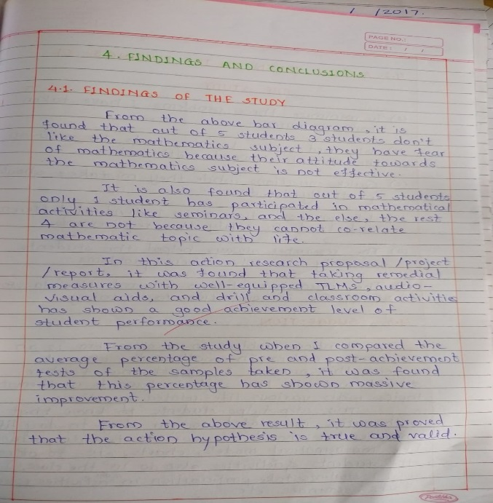

1

Students at Appasaheb Birnale College of education to boost their innovativeness get opportunities to celebrate important days like …..

1. Liberian day
2. Independence day
3. Teachers day
4. National youth day
5. Republic day
6. Marathi rajbhasha day
7. World women day

Case 2

Self-Study Report of Appasaheb Birnale College Of Education

Teachers encourage students to involve themselves in doing research projects which leads to

Innovative ideas by students. Here the teacher gives detailed orientation about the purpose, meaning

And procedure of research. The research project can be done in the form of a survey or experiment.

Students are expected to work on different problems like Handwriting Problems, Homework,

Attendance, Reading and writing, Communication problems, Disciplinary problems, Disinterest etc,

Thus, the students under the guidance of teachers work on different problems existing in the field of

Education and through their research work they come up with innovative solutions for the same.

INTELLECTUAL AND THINKING SKILLS

In this era flexible thinking and intellectual skills help to process, analyze and combine all sources of information to select the most suitable solution and ability to modify the same if necessary.

Educators at Appasaheb Birnale College Of Education make efforts in this direction of developing these skills Through different tasks.

1

Through the practical course of Drama & Art in Education students at Appasaheb Birnale College Of Education get the opportunity to think intellectually and create scripts for dramatization, and prepare various for street play/skits.

Here the teacher educators give orientation to the students regarding scriptwriting and then the students select any theme like social/educational problems. The group Coordinates and performs in front of the class and prepares reports. In this way the student’s utilize and develop their intellectual and thinking skills.

EMPATHY

Empathy involves experiencing another person’s point of view, rather than just one’s own.

Empathy helps us cooperate with others, build friendships, make moral decisions, and intervene

When we see others in trouble.

1

The Practical course of “Understanding the Self” in the B.Ed. courses at Appasaheb Birnale College Of Education provide teachers an opportunity to develop sensibilities, disposition, and skills that will later help them in the personal growth of their own students while they teach. The activities involved like understanding themselves in relation to their students and classroom situations, studying the issues of adolescence, studying case studies of different children who are raised in different circumstances. All these activities are done by the student teachers under the guidance of teacher educators to develop the sense of empathy.

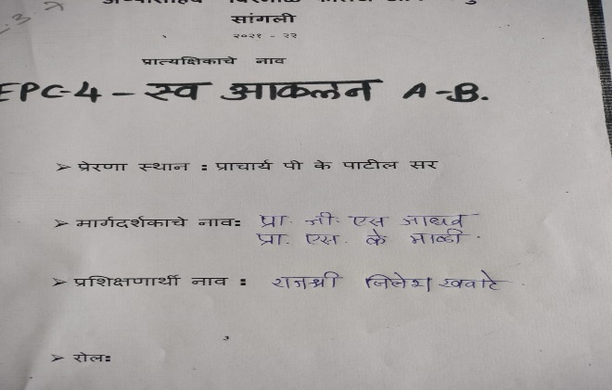

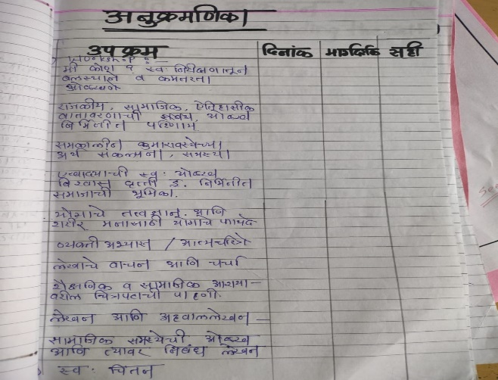

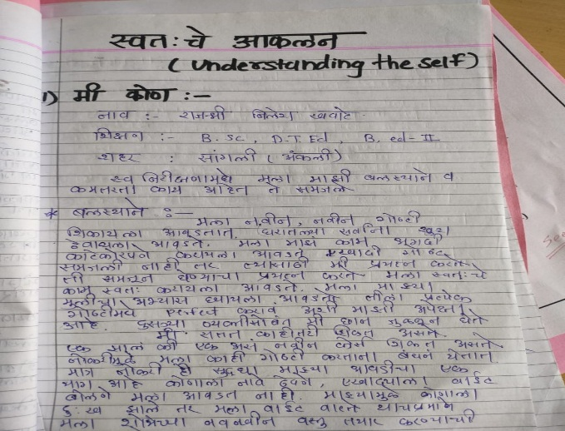

2

The curricular activities at Appasaheb Birnale College Of Education provide an opportunity to visit any government/non-government Organization just like garment visit, Harman tea visits and etc. Students are required to make a report after observing the culture of the organization that develops a sense of Empathy.

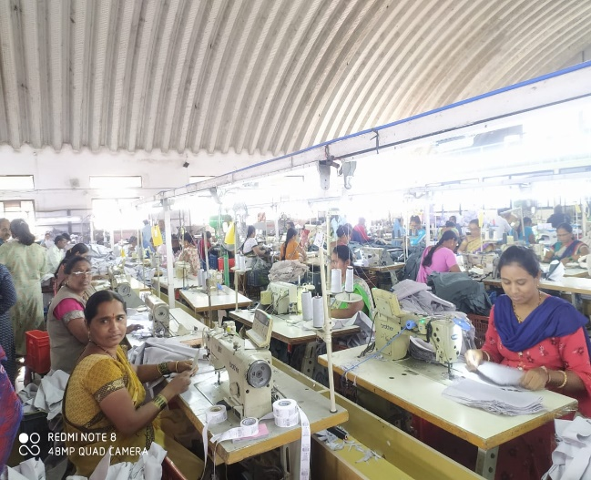

LIFE SKILLS

Life skills is a term used to describe a set of basic skills acquired through learning and/or direct life

Experience that enable individuals and groups to effectively handle issues and problems commonly

Encountered in daily life.

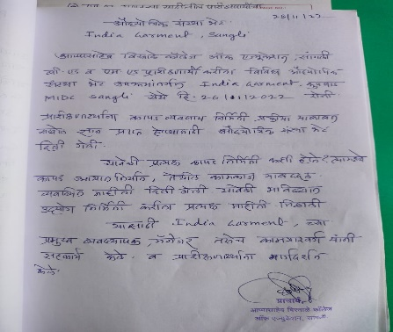

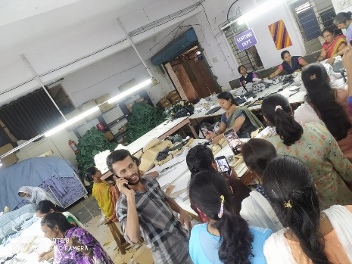

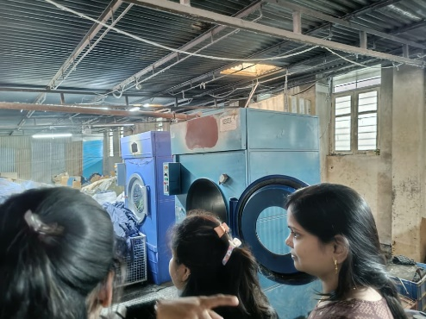

Case 1

Appasaheb Birnale College Of Education organized a Workshop on teacher enrichment. The workshop focused on relaxation techniques and made the teachers and students learn the brain based learning innovative teaching learning methods and adolescent’s periods and its challenges

2.4 Competency and Skill Development

Organizing Learning

Appasaheb birnale college of education is providing a congenial learning environment to students by

catering different learning abilities of the students. It design learning opportunities as per the

curriculum offered by the affiliated shivaji University, kolhapur. Various types of

learning experiences viz. whole class learning, small group learning, peer-group learning etc.

are given to students depending on their needs analyzed by the respective teacher. These

activities are an integral part of the curriculum and carried over the whole session. The learning

activities include reading, writing, speaking, drawing, discussions, presentation by individual

students or in a group, performing, role play etc.. The students are the center point of the

Teaching-learning process. The focus is given to improve student’s ability to inquiry, scientific

temper, linguistic skills for effective speaking & writing, expression etc. Here peer-group

learning plays an important role in enhancing the competencies and skills in students. Teachers

work as a facilitator, plan innovative activities and motivate students to participate in

these activities, and monitor their progress too. Students' role is not only limited to

participation, but they are the observers in the activities and provide feed-back also for

improvement. In such a way analyzing and judging capacities are also developed in students.

To cater the needs of Marathi and English medium students, teachers deliver lectures bilingual

and provide content in both Hindi and English languages.

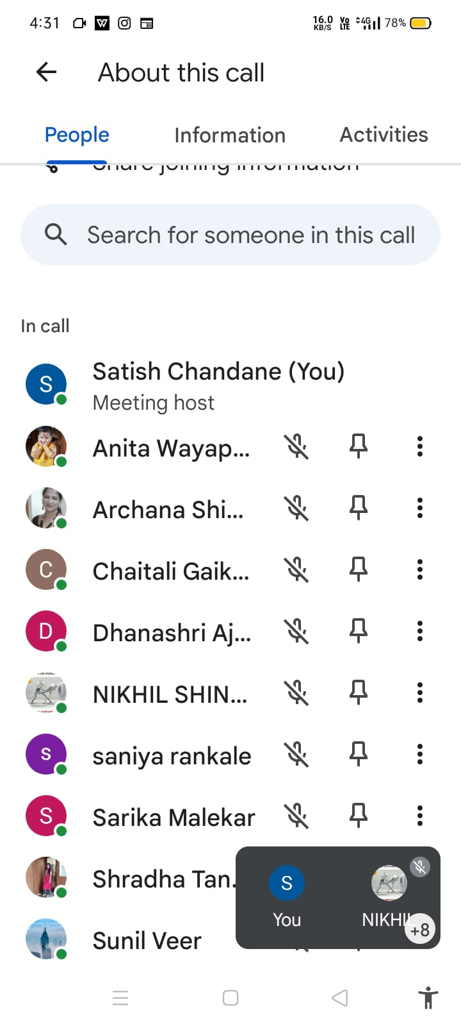

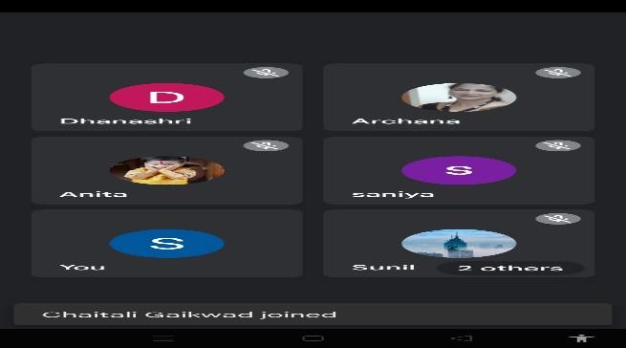

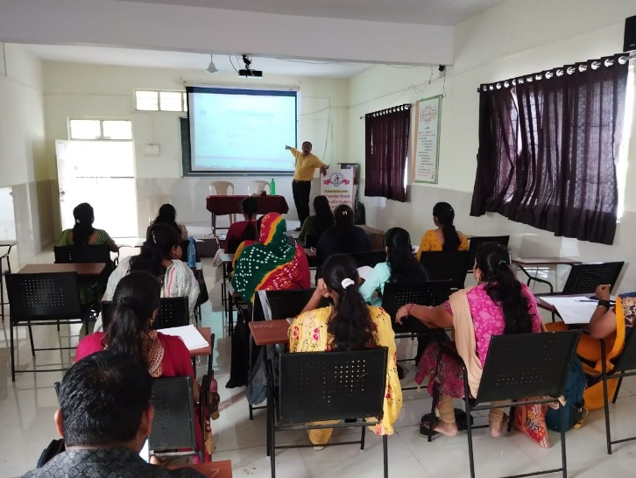

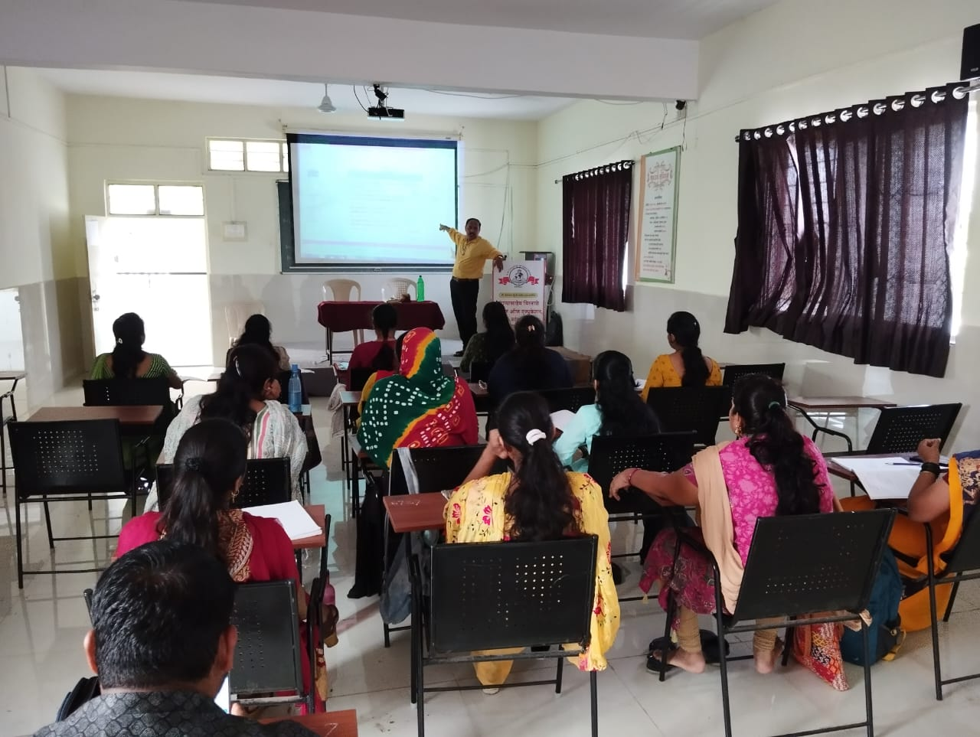

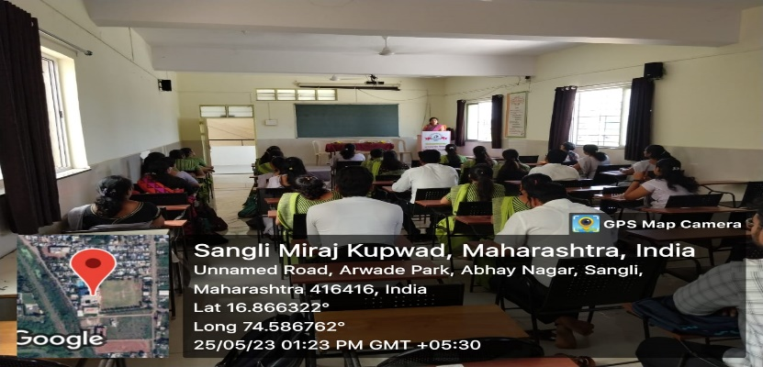

2.4.1 Institution provides opportunities for developing competencies and skills in different functional

Areas through specially designed activities / experiences that include

1. Organizing Learning (lesson plan)

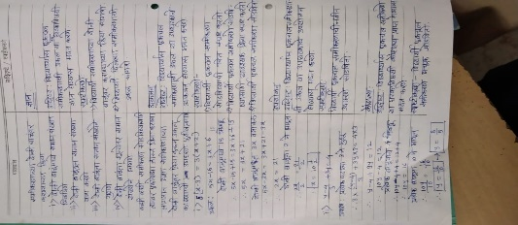 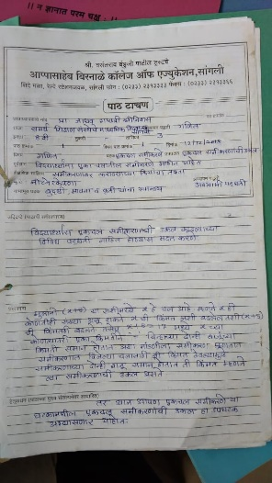 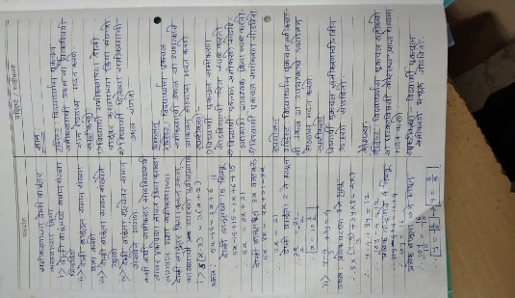 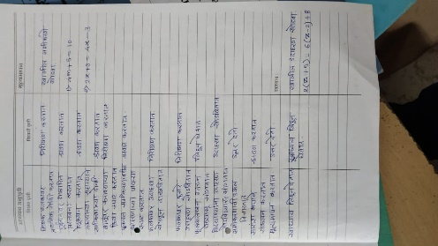 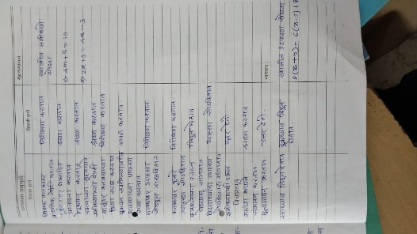 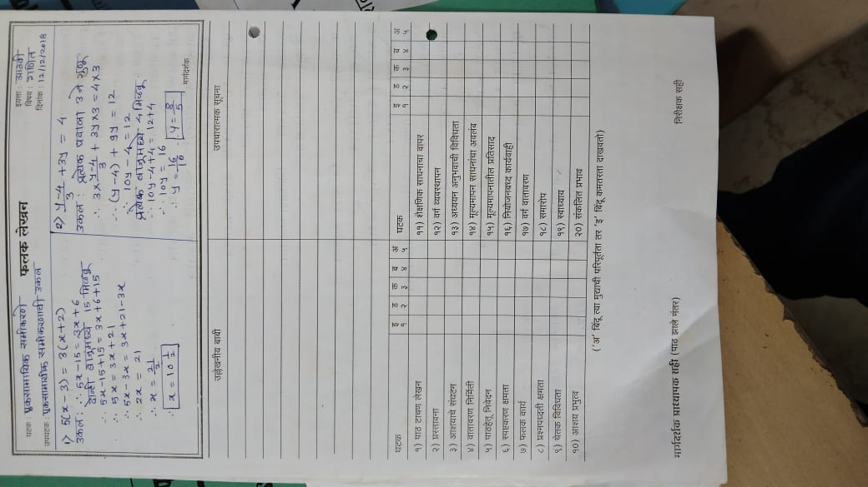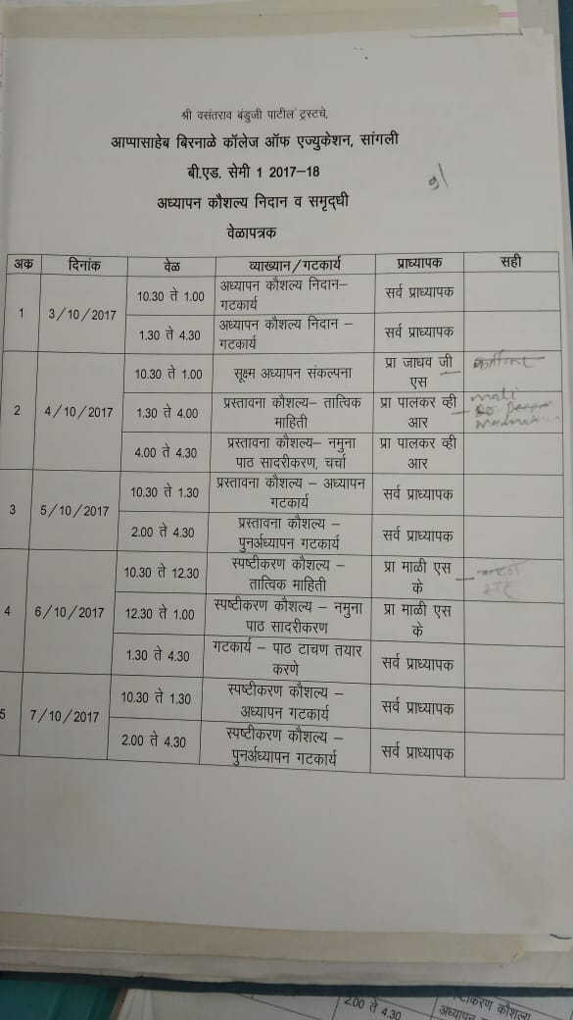 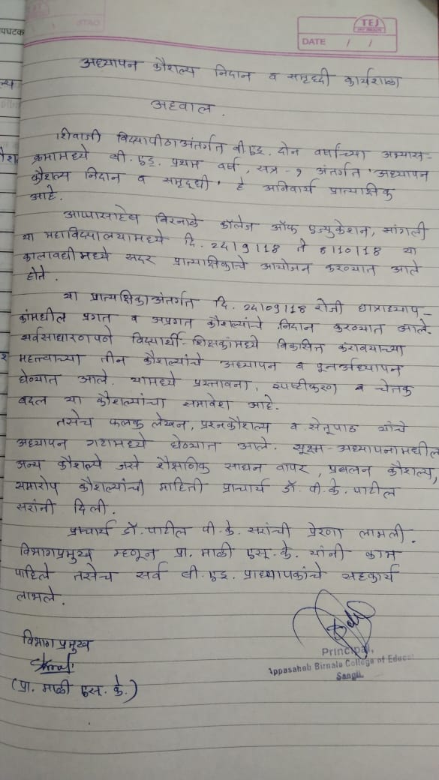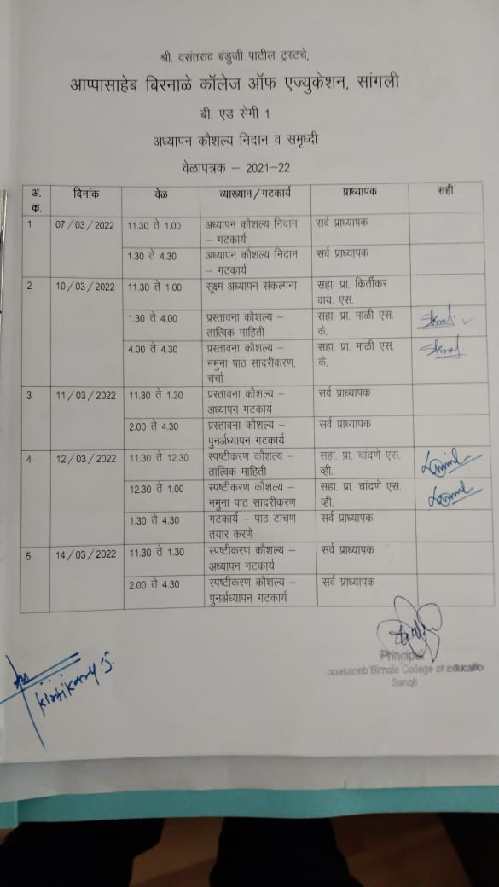

2. Developing Teaching Competencies

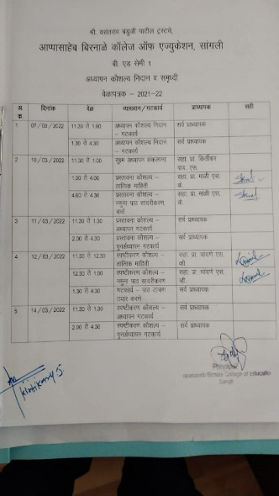 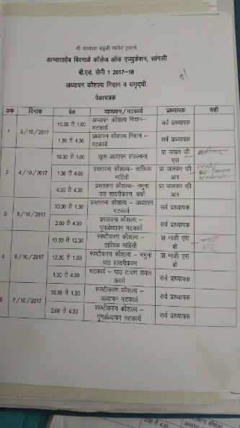 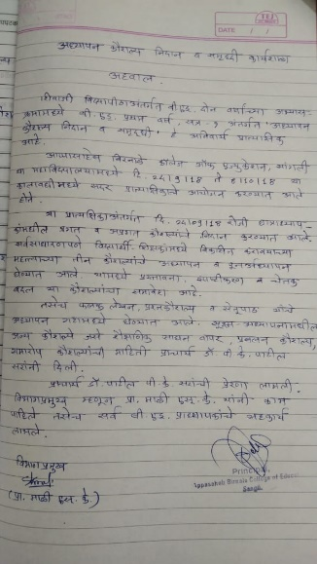 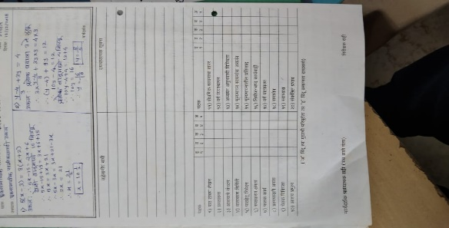

3. Assessment of Learning

4. Technology Use and Integration

5. Organizing Field Visits

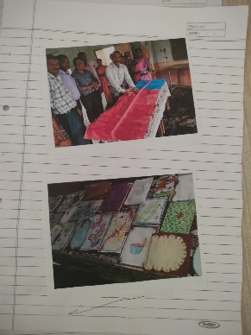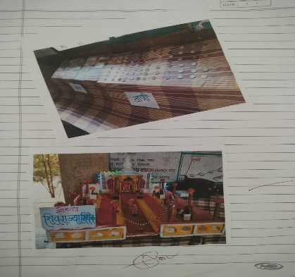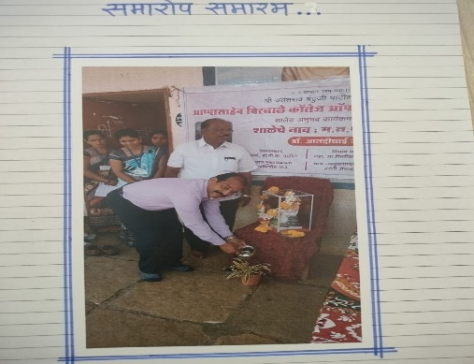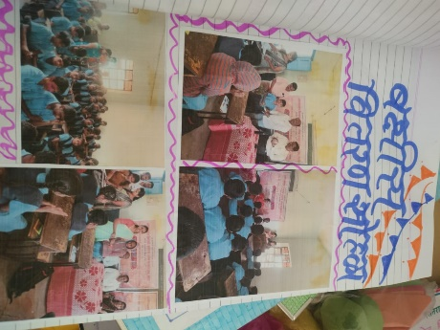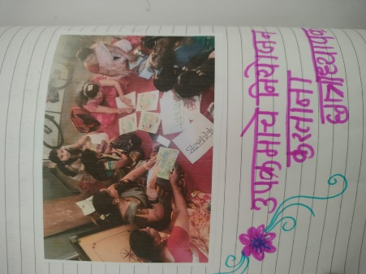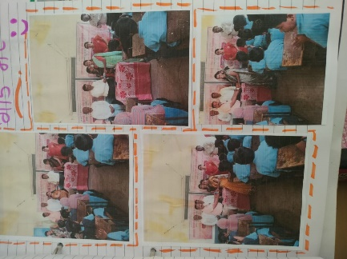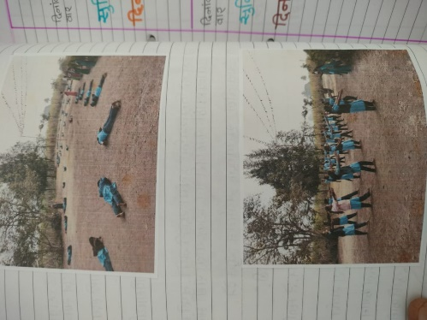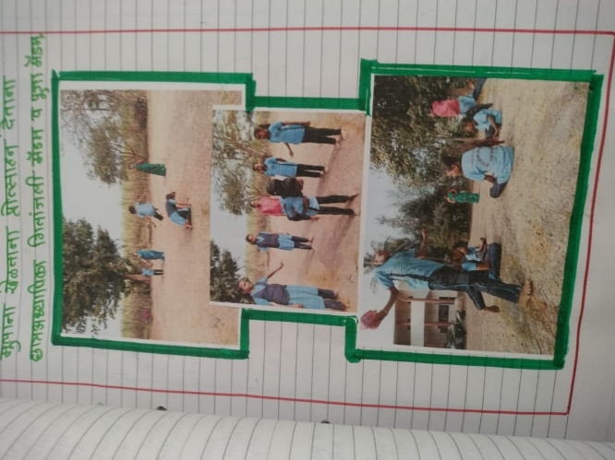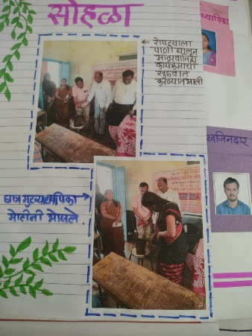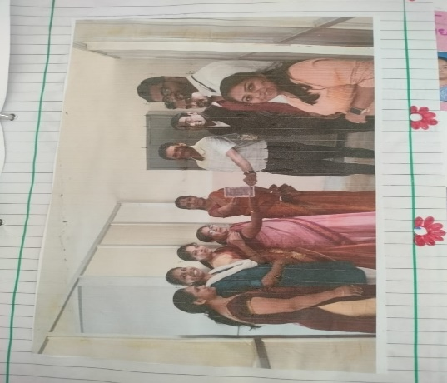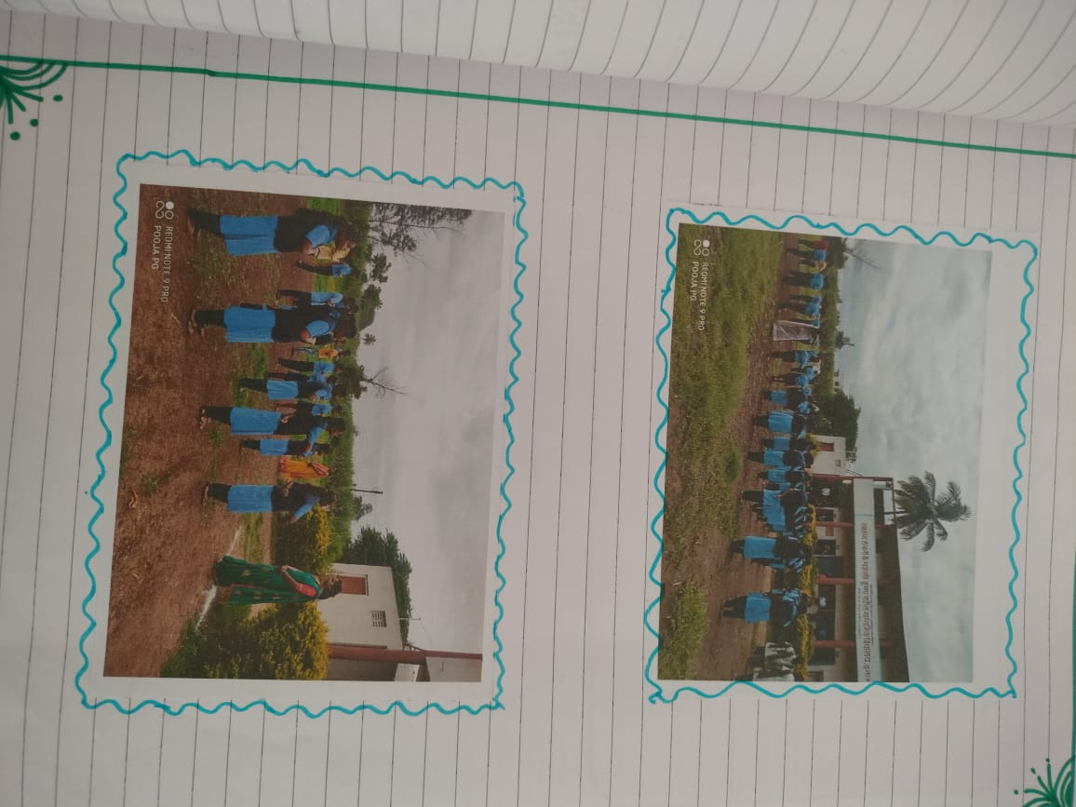

7. Community Engagement



8. Facilitating Inclusive Education

**Ramp**

**Lift**

**Books of B.Ed. students (subject creating an inclusive school and special education)**

9. Preparing Individualized Educational Plan (IEP)